Exercise 3: Routing tables

01 - Examine routing tables
Open the packet tracer network “Exercise 3 - 01 - Examining routing tables.pkt” provided on Canvas.

Topology
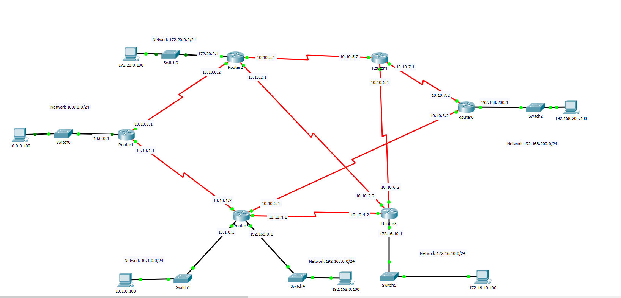

Don’t be intimidated by the size of the network. You don’t have to configure anything yourself. The network is already configured for you! In this network, there are 6 networks on which end devices are connected (10.0.0.0/24, 10.1.0.0/24, 192.168.0.0/24, 172.16.10.0/24, 192.168.200.0/24 and 172.20.0.0/24). Each connection between 2 routers is a network as well with ip addresses in the 10.10.0.0/16 range (e.g. between Router1 and Router2 is the network 10.10.0.0/24).
  - Can you find all 14 networks with their ip address range?
As mentioned before, this network is already configured, you don’t have to change or configure anything yourself in this network.
- End devices, switches and routers are connected. The connection between routers is a serial connection.
- The ip addresses, subnet masks and default gateways of all the end devices are configured.
- The ip addresses of all the router interfaces are configured.
- A dynamic routing protocol (in this case RIP) is enabled on all the routers. You don’t have to be able to configure this yourself! You don’t have to know the name of these protocols or how these protocols work, you only have to know they exist.
- Some static routes are configured in Router1 and Router2.

- Open the command prompt on computer 10.0.0.100 and ping to 192.168.200.100.
  - Were the pings successful
  - It is possible that the first and second ping are not successful. With Assignment 5 in mind, can you explain why?
By looking at the network, there are several routes through the network from 10.0.0.100 to 192.168.200.100. For example over Router1, Router3 and Router6. This route has a hop count of 3 because packets following this route traverses 3 routers (= hops).
  - Can you find a route from 10.0.0.100 to 192.168.200.100 with a hop count of 4 and a hop count of 5?
  - What route with a hop count of 3 can a packet traveling from 192.168.200.100 to 10.0.0.100?
The route a packet will travel is defined in a routing table. Each end device and each router has its own routing table.
- Open the Router1’s CLI and in the privileged mode (router>enable), enter the following command to see the routing table (if you see “--More--” at the end of the table, press enter until you can see the entire routing table):
    - Router1#show ip route
There are 5 types of routes in this specific routing table
- L: The link local ip address of a specific interface
= the ip address of interface GigabitEthernet 0/0 is 10.0.0.1
- C: A directly connected network
= the network 10.0.0.0/24 is directly connected to interface GigabitEthernet 0/0. Packets with a destination ip address in this range can be send out this GigabitEthernet 0/0 link.
- R: A route to a network discovered by the dynamic routing protocol RIP
= packets with destination ip address in the 10.1.0.0/24 network must be forwarded to the device with ip address 10.10.1.2 on the interface Serial 0/0/1

The process is as followed: This router receives a packet with, for example, destination ip address 10.1.0.100. The router will remove the Source and Destination MAC address of the incoming packet, It will search for the MAC address of 10.10.1.2 (ARP table or with ARP request). It will add this MAC address as destination MAC address to that packet and forward this packet on link Serial 0/0/1. Router3 will receive this packet, search it’s routing table, and do the same with the incoming packet (Remove MAC addresses, add new MAC addresses to the next hop), and so on.
It is possible that a destination network has more than one route in the routing table. In this case the router will alternate (load balance) between these routes.

= the first packet with a destination ip address to the 10.10.6.0/24 network will be send via 10.10.1.2 on Serial 0/0/1, the second via 10.10.0.2 on Serial 0/0/0, the third again over 10.10.1.2, and so on.

- S: A static configured route (= manually configured route). A static route will override any dynamic routes to that specific network. You can see that the administrative distance for a route discovered by RIP is 120, while the administrative distance of a static route is 1. Only the route with the lowest administrative distance is displayed in the routing table.
= packets with a destination ip address in the 192.168.200.0/24 network will be forwarded to 10.10.0.2
- S*: A static default route

= packets with a destination ip address to a network that is not listed in this routing table will be forwarded to 10.10.0.2. This is the router’s “Default gateway”.

Figuring out the path a packet travels through the network.

To find the path a packet travels through a network, you will have to examine the routing table of each router to find the next router.
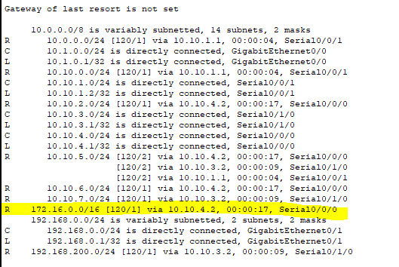
- We will ping from computer 10.1.0.100 to computer 172.16.10.100. The Ping request will travel from computer 10.1.0.100 to computer 172.16.10.100 through the network.
The default gateway of computer 10.1.0.100 is router 10.1.0.1. Open the CLI of Router3 and show the routing table. (Router#show ip route)
- The next router to the 172.16.0.0/16 network is the router with ip address 10.10.4.2, which is Router5.

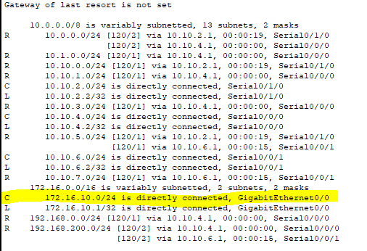
- Examining the routing table of Router5 reveals that network 172.16.10.0/24 network is directly connected. Which means that this is the last router and the packet can be send from Router5 to computer 172.16.0.100
- This information is already filled in in the table on the last page.

- The Ping reply travels from computer 172.16.10.100 to computer 10.1.0.100. Figure out the route this packet travels through the network by examining the routing tables and fill in the table on the last page.
- To check your solution, enter the simulation mode, open the command prompt on computer 10.1.0.100 and ping to 172.16.10.100. Click the “capture forward” button to see the packet traveling through the network.
  - The TTL (Time to live) of an ICMP message starts with 128. Each router will decrease this TTL with 1. What will the TTL be of a ping reply when it is received by the command prompt of computer 10.1.0.100?
  - What is the TTL used for?
- Another way to check which routers a packet travels over to a remote network is to use the traceroute command. Open the command prompt of computer 10.1.0.100. Activate the real time mode of packet tracer. The following command will list all the routers a packet traverses.
    - C:\>tracert 172.16.10.100

- Figure out the route a Ping request and reply will take if you ping from computer 10.0.0.100 to 192.168.200.100. Fill in the table and check the route that you found by following the ICMP packets using the simulation mode in packet tracer and by using the traceroute command.
  - Can you see that the Source and Destination MAC address changes after each router, but that the Source and Destination IP address stays the same?
- Power off Router4 and repeat the previous exercise.
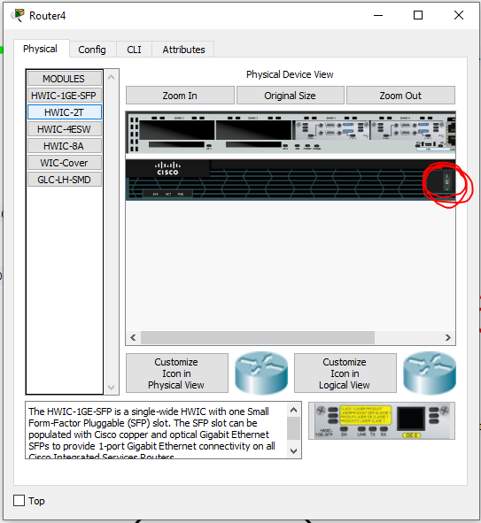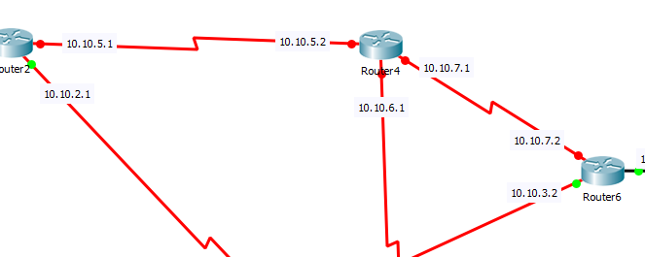
- Figure out the route a Ping request and reply will take if you ping from computer 10.0.0.100 to 172.20.0.100. Fill in the table and check the route that you found by following the ICMP packets using the simulation mode.
- Close packet tracer and re-open the packet tracer file in order to get the fully working network back (with router4 back on and all routes to this router restored)
- Figure out the route a Ping request and reply will take if you ping from computer 172.16.10.100 to 192.168.200.100. Fill in the table and check the route that you found by following the ICMP packets using the simulation mode in packet tracer. Make sure that you examine all 4 ping request and reply packets.
  - Why do the ping request packets travel over different routers each time?

You can see how dynamic the routing process is. Packets can travel through a network using different paths, load balance between paths and use alternative paths when a device or link fails.
Using the simulation mode, you can experiment a little bit more. Remove devices, delete links and see how the routing process evolves. But if you remove to many links or devices, it is possible that a specific network is not reachable anymore. You can always reopen the original .pkt file to start over. The network 172.20.0.0/24 is only reachable from network 10.0.0.0/24.

02 - Configuring a static route
Open the packet tracer network “Exercise 3 - 02 – Configuring a static route.pkt” provided on Canvas.

Topology

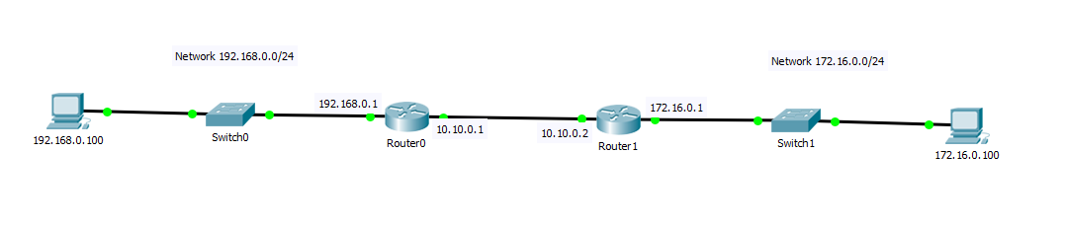
A part of this network is already configured:
- End devices, switches and routers are connected. The connection between routers is a serial connection.
- The ip addresses, subnet masks and default gateways of all the end devices are configured.
- The ip addresses of all the router interfaces are configured.

There are no routes routes configured in the routers, only the directly connected networks and the link local ip addresses are listed in the routing tables.
- Open Router0’s CLI and examine the routing table.
  - Will a ping from computer 192.168.0.100 to 172.16.0.100 be successful? Why not?
- Try to ping to 172.16.0.100 from command prompt on computer 192.168.0.100.
  - What is the response in your command prompt?
  - Which device is sending this response?
- Try to ping from computer 192.168.0.100 to 192.168.0.1 (= default gateway)
  - Where the pings successful?
- Try to ping from computer 192.168.0.100 to 10.10.0.1
  - Where the pings successful?
- Try to ping from computer 192.168.0.100 to 10.10.0.2
  - Where the pings successful?
  - What is the response in your command prompt?
  - Why do we get a request timeout message, rather than a destination host unreachable as before?
- Enter the simulation mode and try to ping from computer 192.168.0.100 to 10.10.0.2. Capture forward and see where the ping fails.
Every packet has a destination ip address.
When computer 192.168.0.100 sends a ping command to 172.16.0.100, a ping request is generated by computer 192168.0.100 with destination ip address 172.16.0.100. This packet is send to the default gateway (192.168.0.1 = Router0), this router searches for the network of the destination ip address in the routing table. This network is not found and therefor Router0 responds with a “destination unknown” packet.
When computer 192.168.0.100 sends a ping to 10.10.0.2, it sends a ping request with destination ip address 10.10.0.2 to the default gateway (192.168.0.1 = Router0). This router searches for the network of the destination ip address in the routing table. The network is directly connected and therefor the packet can be forwarded to 10.10.0.2 (=router1). Router1 generates a ping reply with destination ip address 192.168.0.100, searches its routing table and sees there is no route to this destination network and therefor has to drop this packet. Computer 192.168.0.100 receives no response and the request times out.
To fix this problem, we need to enter a route to the 192.168.0.0/24 network in the Router1’s routing table, and a route to the 172.16.0.0/24 network in the Router0’s routing table. We will use a static route.
- Open the Router0’s CLI and enter the following command (in the global configuration mode) to enter a static route
    - Router0(conf)#ip route 172.16.0.0 255.255.255.0 10.10.0.2
= ip route ‘destination network’ ‘destination network mask’ ‘next hop ip address’
  - Can you see this route in the routing table?
- Open the Router1’s CLI and enter the following command to enter a static route
    - Router(config)#ip route 192.168.0.0 255.255.255.0 10.10.0.1
  - Can you see this route in the routing table?
- Ping from computer 192.168.0.100 to computer 172.16.0.100.
  - Where the pings succesful?

“01 - Examine routing tables”-table

 | Hop 1 | Hop 2 | Hop 3 | Hop 4 | Hop 5 | Hop 6 | Hop count/TTL of the reply
Ping request from 10.1.0.100 to 172.16.10.100 | Router3 | Router5 |  |  |  |  | 2/126
Ping reply from 172.16.10.100 to 10.1.0.100 | Router5 | Router3 |  |  |  |  | 2/126
Ping request from 10.0.0.100 to 192.168.200.100
Ping reply from 192.168.200.100 to 10.0.0.100
Power off Router4

Ping request from 10.0.0.100 to 192.168.200.100
Ping reply from 192.168.200.100 to 10.0.0.100
First Ping request from 172.16.10.100 to 192.168.200.100
First Ping reply from 192.168.200.100 to 172.16.10.100
Second Ping request from 172.16.10.100 to 192.168.200.100
Second Ping reply from 192.168.200.100 to 172.16.10.100

